# Cott_Logo(NEW)[1]

**Starters**

Prawn cocktail, Marie Rose sauce, dressed leaves, bread & butter (g) (s) (d) £9.50

Crispy camembert wedges with chilli jam, crostini, leaves (g) (d) £9.50

Goats cheese & pea arancini, pesto aioli, rocket & parmesan salad (d) (g) (n) £9.00

Chicken & mushroom liver parfait brûlée, red onion marmalade, grilled brioche (d) (g) £10.00

Squid croquettes, aioli, salsa verde, dressed leaves (g) (d) (s) £9.50

**Mains**

Roast Dartington ‘Ruby Red’ beef, Yorkshire pudding, horseradish hollandaise (g) (d) £19.95

Roast West Country lamb, Yorkshire pudding, mint hollandaise (g) (d) £19.95

Roast chicken breast, Yorkshire pudding, stuffing, bread sauce (g) (d) £19.95

Roast loin of pork, stuffing, Yorkshire pudding, crackling, apple sauce (g) (d) £19.95

Mixed roast, choices of beef, lamb and pork, Yorkshire pudding, stuffing, crackling (g) (d) £24.00

Vegetarian chestnut roast, red wine vegetarian jus, glazed parsnip and potatoes (v) (n) (g) £18.95

Pan fried seabream fillet, dill & lemon crushed potatoes, buttered greens, tartar sauce emulsion, squid croquette (d) £19.00

Sweet pea ravioli, sin dried tomato, white wine & cream sauce, rocket, toasted hazelnuts & truffle oil (d) (g) (n) £18.00

Seafood chowder: selection of Plymouth-landed fish, mussels, king prawns in white wine, saffron & cream, grilled sourdough, lobster aioli (d) (g) (s) £20.00

Ginger beer & soda battered Plymouth-landed fish, chips, pea puree, lemon, tartare sauce £19.00

Crispy Camembert salad, beetroot, peppers, balsamic onions, pickled walnuts, chilli jam, crispy onions, tomato chutney, warm sourdough (v) (d) (g) (n) £19.00

Chargrilled ruby red burger, smoked bacon, onion rings, Monterey Jack cheese, brioche bun, fries, tomato chutney & baconnaise, (g) (d) (sesame) £19.00

Seafood salad- prawn Marie Rose sauce, smoked mackerel pate, crevette, smoked salmon, lobster aioli, crispy capers, grilled sourdough, salsa verde, new potatoes (s) (g) (d) £19.00

*All our roasts come with a selection of vegetables, Yorkshire pudding, roast potatoes and gluten-free red wine gravy*

**Desserts**

Gluten-free sticky toffee pudding with salted caramel ice cream (d) £9.00

Apricot cream cheese cake, vanilla cream Patisserie, Chantilly cream, berries (d, g) £9.00

White chocolate & passion fruit panna cotta, macaron, berries (d) (n) £9.00

Salted caramel chocolate tart, hazelnut praline, clotted cream (d) (g) (n) £9.00

Vegan chocolate ganache, kirsch soaked cherries, raspberry crumb (ve) (n) £9.00

Selection of Yarde Farm ice creams or sorbets (d) £9.00

Selection of 3 cheeses, biscuits, celery, tomato chutney (g) (d) £13.00

**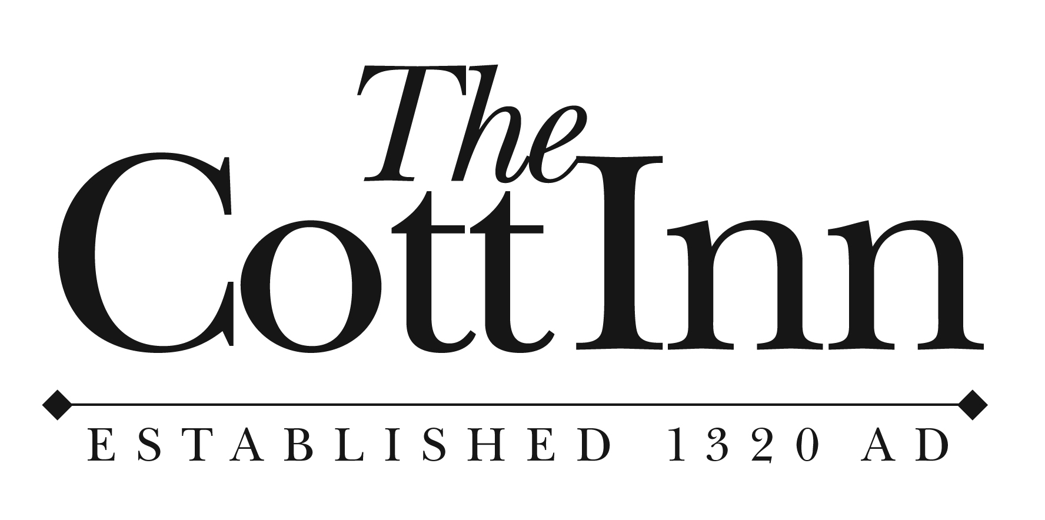**

## Children’s Menu - £9.95

***All dishes include one scoop of Yarde Farm ice cream***

**Kid’s cheeseburger, brioche bun, skinny fries**

**Kid’s fish & skinny fries**

**Kids mini roast dinner (under 14 only)**

**Kid’s nut roast (n)**